Northern University Bangladesh



**Lab report:** 04

**Department:** CSE

**Course title:** Digital Electronics & Pulse Technique Lab Work

**Experiment no:** CSE 2366

**Experiment name:** Implement Diode Transistor Logic (DTL) NOR, Transistor Transistor Logic (TTL) NOT gate in Tinkercad

**Submitted by** **Submitted to**

Name of teacher: Nizia Nahyan

Designation: Lecturer

Signature:

Name: Fardeen Ahmed

Id: 41210301615

Date of Experiment: 01/7/2024

Date of submission: 7/7/2024

DTL NOR gate

Circuit diagram:

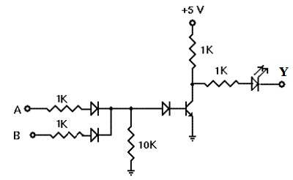

Circuits Screenshot:

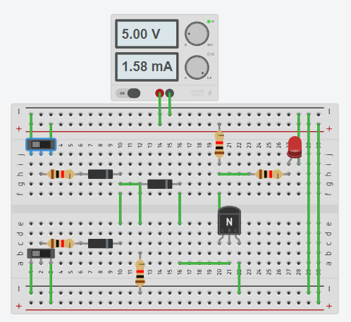

Tinkercad circuit link:

<https://www.tinkercad.com/things/aAvRTDV0w2t-dtl-nor-1615?sharecode=qnu3PHJcdNuDzOI0rOjzjnUVRqqlJcxqwxPAvDXqkyo>

TTL NOT gate

Circuit diagram:

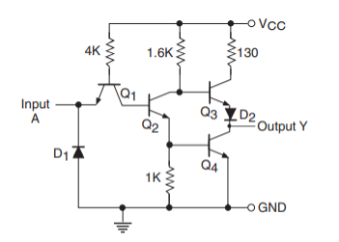

Circuit screenshot:

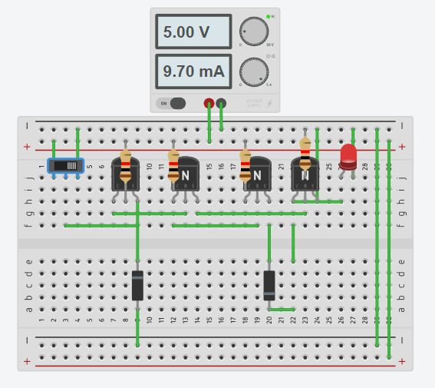

Tinkercad circuit link:

<https://www.tinkercad.com/things/8hWCwrv1LUs-ttl-not-1615?sharecode=CYD3XrIbgKHVrdeCHDFepEWlSpyqHY_azTGf97SIqpg>